
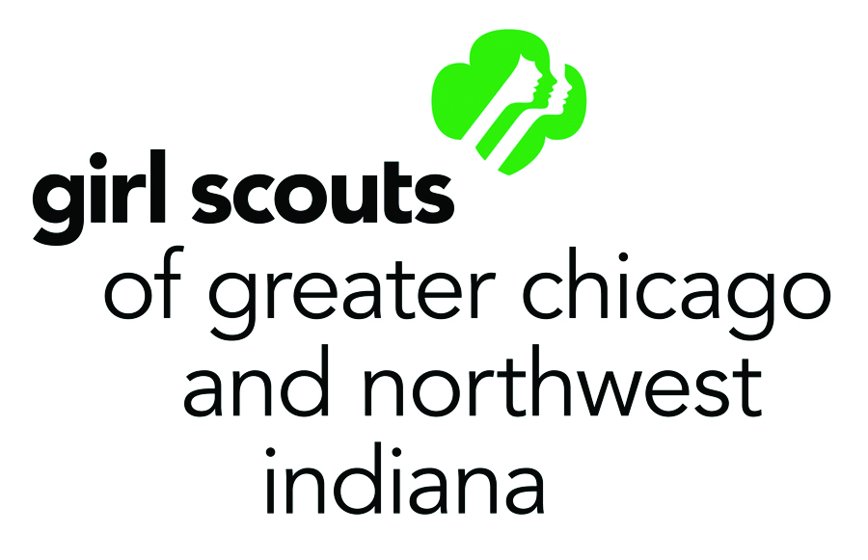
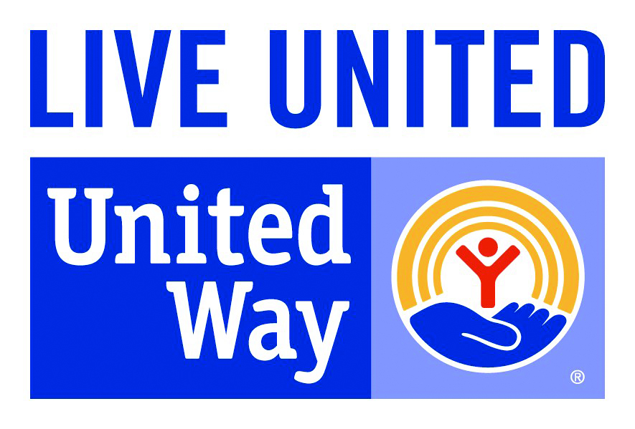
I can’t wait to be a Girl Scout!
What do Girl Scouts do?
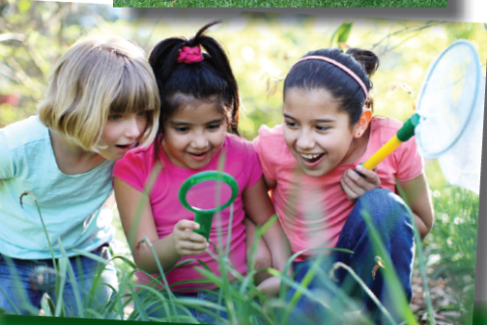
Girl Scouts earn badges, hike and camp, participate in the cookie program, and much more. They improve neighborhoods, protect the planet, design robots, and establish sports clinics. As a Girl Scout you will make new friends, create long lasting memories and have FUN!
Girl Scout Grade Levels
Daisy: K - 1st grade Brownie: 2nd - 3rd grade Junior: 4th – 5th grade Cadette: 6th – 8th grade Senior: 9th – 10th grade
Ambassador: 11th – 12th grade
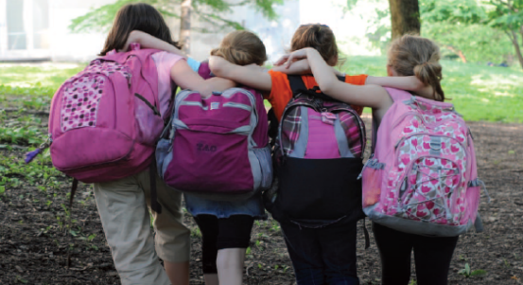

Calling all 3rd Grade Girls!
A NEW Brownie Girl Scout Troop at Walker Elementary is forming NOW! We are looking for girls and their parents who are interested in joining the FUN!
Please contact us for more information.
Girl Scout Volunteers (Troop/Group Leaders and Helpers) Girl Scouts that belong to a troop or group are guided by leaders-community volunteers who are parents or other adults trained by the local Girl Scout council. Leaders work with girls to determine interest and decide on activities within the framework of the Girl Scout program. Parents are asked to help support the leaders by helping where needed, such as with transportation, group snacks (if needed), helping at meetings or family outings. As a Girl Scout Volunteer you’ll serve as a partner and role model to girls, discover your own skills and abilities, meet new people, and “learn by doing” alongside girls at every step.
Questions: Jennifer Davis, School Parent RHINEGIRL03@yahoo.com
Marie Erbeck, Membership Specialist merbeck@girlscoutsgcnwi.org 630-544-5905

